Hotdogs: A name by chance!

Being a foodie, I love cooking various recipes across the globe. It is when recently I recognized my interest in penning down some of the interesting facts about food. I am nowhere a master in cooking. But a big thanks to my mom for briefing out my interest in cooking. [**ThinkNSay**](https://thinknsay.in/) has opened me through words and helps me reach the soul of my readers. Let's start with a **drooling Hotdogs History!**

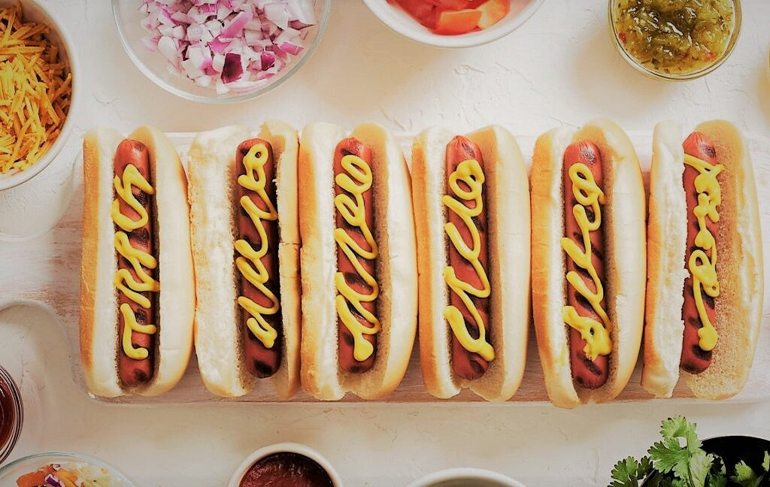

*Set of hotdogs ready to be served with seasonings, herbs, and additions.*

**What's a Hotdog?**

**Hotdog is popular American street food in which the cylindrical-shaped bun cut partially from between to fill with sausage and other stuff like sauces, etc. A sausage is a lump of minced ground meat shaped cylindrically, often, steamed, and later grilled.**

**The backstory:**

**Hotdogs were never historical or traditional cuisines of America.** Let's be honest. It was a quick adaptation later transformed and recreated, making it one of their staple street foods. The adaptation, after all, started in the 20th century in the US.

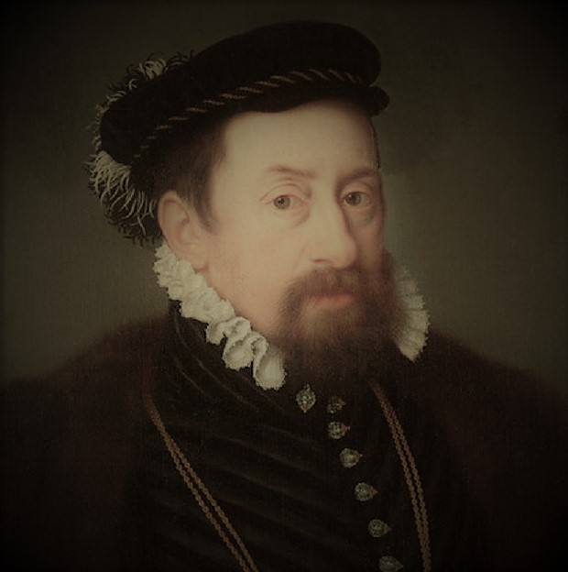

*Painting of Maximillian II, The Holy Roman Emperor. his coronation ceremony was marked to be the invention period of the original Frankfurters/Wiener.*

Funny fact is the sausage of the hotdogs are as old as the 16th century period. The reason is it all started in Rome. To mark the successful successorship of **Maximillian II, the Holy Emperor of Rome**, sausages were invented out of pork meat only. These sausages were said to have invented by an Austrian Chef during the King's Coronation. But these sausages were never called sausages but **"Wiener"** as it referred to Vienna, the capital city of Austria. The invention of these sausages/ wiener was never served with buns or bread as the sausages were alone enough to complete a dish.

**What a Claim!**

Everything went steadily until the 18th century. A German butcher claimed these cylindrical meat recipes were not of Austrian origin. Instead, they were originally German. It was brought to Austria from Germany, long back in the 12th or 13th century, to serve the taste buds of the new Roman King.

Well you see, when things go popular, there is always someone at the corner to claim its own! No offense, but we are left in dark to understand the old history.

When Germans finally realized their authentic dish going so popular, they tried to popularise it by selling them fresh on streets with small carts. There was no evidence of calling this meat dish as sausages, until then. Germans love calling it "**Frankfurter**". They believed it to have originated from Franconia, Coburg, Germany. Yes, you heard right. Coburg is home town to Prince Albert, King Consort to Queen Victoria of the United Kingdom. Phew! what a claim!

**Hotdogs are American?**

Let's call it Frankfurters for a while, these meat recipes resembling pipe structured small intestines were now sold out of Germany. Moving out of Europe traveling to the American subcontinents, German immigrants started **selling these Frankfurts in the streets of St. Louis, Missouri.** This was finally the first landing of the sausage culture outside Europe.

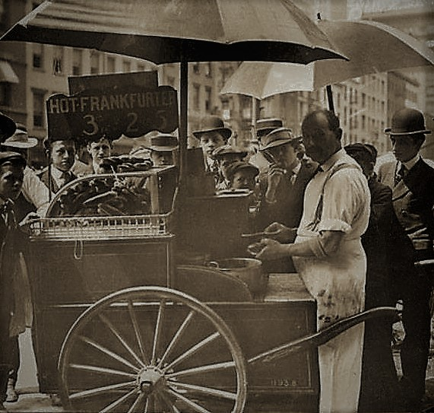

*A black and white photograph from the late 18th century when hotdogs were new to Americans.*

The Frankfurts were sold hot and fresh on small pushcarts on the streets of Missouri. They were served along with gloves. The reason was to prevent their customers from burning their hands. Unluckily, people did not return back the gloves. Some even claimed to have taken it away as a souvenir.

*Running loss in the business of Frankfurts due to gloves, the German immigrant's wife suggested replacing the gloves with buns. these buns were cylindrical to fit the sausages perfectly within it. Decorated with mustard sauces, ketchup, mayonnaise, onions, and later cheese, there was a final shape of what we call today a Hotdog! Today Hotdogs are a kind of national street food to the American subcontinent.*

**Why Hotdogs are called Hotdogs?**

***“Literally speaking, Hotdogs have nothing to do with the animal dogs!”***

**Yes, you heard it right! Hotdogs have nothing to do with the animal dogs! Fun fact is, the sausage filled inside the bun was often called Dachshund (in German) or "Little dog" resembling that the Dachshund dog. The crazy link between the little dog and the sausage was that Dachshund was later called a sausage dog or Wiener dog whereas the sausages were called Dachshund. whatever may it be called but the resemblance makes people think link into crazy metaphors.**

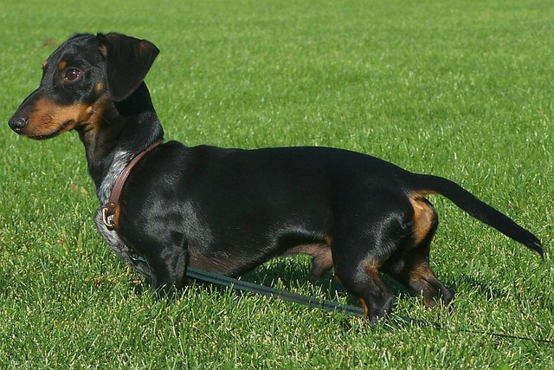

*Dachshund/Wiener dogs are also called hotdog Dogs due to the resemblance in its figure.*

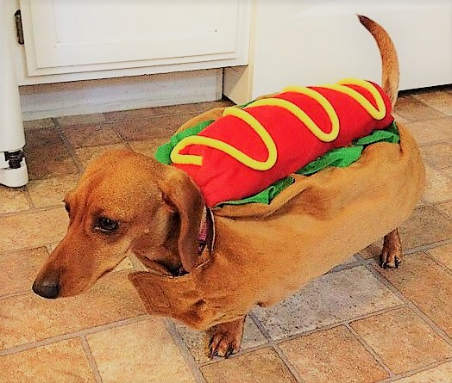

Adorable brown wiener/Dachshund dressed up as a hotdog.

**Until then...**

Have you ever had a Hotdog? Every country has its own version of Hotdogs, and India is nowhere left behind to recreate it in its own style. Comment down below which version of Hotdog you had or willing to have.

We will meet soon with a new extraordinary backstory of another dish, let me hint you.........it's so close to our heart and tradition! Shhhh! hail the suspense. Till then you can read some spicy [filmy stories](https://thinknsay.in/category/movie/) and wait for the next!